Welcome

to

Mrs. Caudill’s and Miss Grant’s

Kindergarten Class

2021-2022

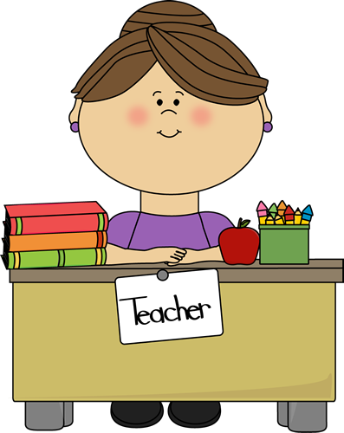

**Welcome to Kindergarten!**

**I am excited to be your child’s teacher this year! We are looking forward to an exciting school year filled with many fun learning opportunities.** **The activities will incorporate instruction and skill reinforcement in reading readiness, mathematics, writing, science and social studies, fine and gross motor skills, social/emotional skills and language development. I’m especially excited to teach your child how to read by giving them the foundations of phonics to be successful!**

**I encourage parental participation and support, so please feel free to contact me throughout the school year. I want to be your partner in supporting your child in any way. I am providing this packet to help answer questions you may have concerning procedures, conduct and communication.**

**Contact Information:**

**Email: caudist@boe.richmond.k12.ga.us**

**School Phone: 706-771-2881**

**\*\*Please leave a message and I will return your call as soon as possible.**

**Transportation – All transportation changes must be in writing! We cannot take your child’s word! Notes can be sent in your child’s folder the morning of the change. In case of an emergency, call the office to notify us of a change.**

**Arrival - School day hours begin at 8:15. Breakfast will begin at 7:55. If your child needs to arrive before 7:55, they need to be enrolled in Prime Time. This is for your child’s safety. Students arriving AFTER 8:15 will be marked tardy. Please be mindful of these procedures. They are set for your child’s safety.**

**Homework- Homework is to be completed each night and returned the following day. Students will need crayons, handwriting paper, pencils, a pair of scissors, and a glue stick to keep at home. Supplies will NOT be sent home daily.**

**News - Please check your child’s folder daily for information that may be sent home about upcoming class or school events.**

**Conduct - Good behavior is expected and important to ensure a productive learning environment. Your child will have a behavior update in their folder daily that will be colored based on the events of their day. Please initial daily to ensure that it has been reviewed.**

**Change of Clothes - Accidents happen! Please provide a change of clothes labeled with your child’s name in a Ziploc bag to be kept in their cubby. Please send a seasonally appropriate shirt and bottom, socks and underwear. They may not have a bathroom accident, but have a spill at lunch or any other type of accident that may result in the need to change. It is important to have clothes so if an accident happens your child will have something to change into.**

**Lunch - Free breakfast and lunch will be provided daily. Your child will be provided with a lunch number. Please help them learn this number ASAP. I will send the number in your child’s folder as soon as I receive them. Per district policy students are not allowed to bring**

**Money sent in for any reason must be sent in an envelope or Ziploc bag labeled with your child’s name.**

**Canvas-This year Richmond County will be utilizing the online learning platform called Canvas. Every student has access to this program through their Launchpad. Canvas will be where your students will access all of their assignments for online/at home learning. There are helpful links on understanding more about Canvas on the Diamond Lakes Webpage and the RCBOE webpage. I can also assist you in your efforts.**